# Color PASBO LogoPennsylvania Association of School Business Officials

# 2608 Market Place Telephone 717.540.9551

# Harrisburg, PA 17110 Fax 717.540.1796

*www.pasbo.org*

*For Immediate Release*

April 28, 2020

**PASBO ESTIMATES SCHOOL DISTRICTS COULD EXPERIENCE $1 BILLION LOSS IN LOCAL REVENUE IN 2020-21**

HARRISBURG (4/28/20)— The PA Association of School Business Officials (PASBO) released their projection of the drop in local revenues for school districts next year the day after the House State Government Committee approved a bill to freeze school district property taxes next year.

PASBO’s estimate of the loss of local revenue is based on a study of the effect of school taxes during the Great Recession and a projection that the COVID-19 economy will create deeper and much more immediate cuts. “Every school district tax source and other non-tax revenue will suffer a precipitous decline for the upcoming school year,” according to Dr. Timothy J. Shrom, PASBO director of research, who developed the PASBO projection with Dr. Andrew Armagost, PASBO research and advocacy manager.

“In an economic downturn we know that unemployment goes up, thereby reducing our local income tax revenue, and we know that the real estate market will be affected resulting in a reduction of our real estate transfer tax We also know that our taxpayers will need more time to pay, thus reducing property tax revenues, and with the significant cuts in the rates, interest earnings will take a hit as well” stated Shrom.

If there is a quick turnaround in the economy, the PASBO data suggests the reduction in total local revenue will be more than $850 million for 2020-21. If the economic recovery lags, however, PASBO projects a loss in total local revenue of $1.07 billion. Currently, school districts collect about $18 billion in total local revenue so the PASBO projected decline represents a loss of 4-5% in total local revenue.

This projected loss in local revenue for school districts comes as the state faces its own financial challenges, creating unprecedented uncertainty for school districts on all revenue fronts for 2020-21.

Adding to the financial challenges and uncertainty, there is no relief for school district mandated cost increases next year. “Despite a COVID-19 economic decline, school districts have no relief on charter tuition costs and special education required services, and those mandated costs will continue to increase regardless of the economic downturn. Next year, we are anticipating a $230 million increase in charter school tuition costs and a $300 million increase in special education costs—that’s a $500 million increase in mandated costs when state revenue is uncertain and local revenue is expected to decline by $1 billion,” said Hannah Barrick, PASBO assistant executive director.

Another challenge is the General Assembly’s continued discussion about freezing school district property taxes at 2019-20 rates. “We believe that school districts will do everything they can to recognize the financial impact that COVID-19 has had on taxpayers, and property tax increases for next year will be considered only in those school districts with no other fiscally viable options,” said Barrick. “School districts simply can’t absorb simultaneous revenue declines at the local and state levels while also facing mandated cost increases.”

[Click here or on the interactive map below to see the estimated range of total local revenue loss for each school district under PASBO’s assumptions for 2020-21.](https://aarmagost.carto.com/builder/abc34f59-5739-4b0e-ae75-a81c2dbaa89c/embed)

[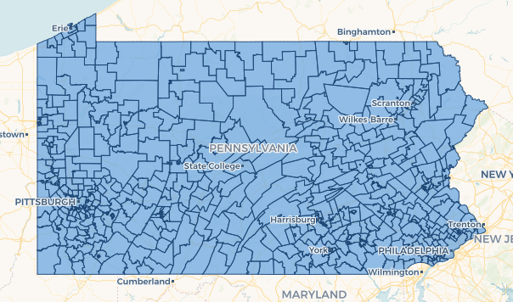](https://aarmagost.carto.com/builder/abc34f59-5739-4b0e-ae75-a81c2dbaa89c/embed)

-30-